UPPSALA UNIVERSITY
Ms. Embedded Systems - 2022
Digital Electronics Design with VHDL
TEMPERATURE LOGGER
SUBHANG VEMPATI

14-05-2022

Contents
- ABSTRACT 3
- INTRODUCTION 4
- PROJECT DESCRIPTION 4
- IMPLEMENTATION AND SIMULATION 6
  - CLOCK DIVIDER . . . . . . . . . . . . . . . . . . . . . . . . . . . . . . . . . . . .. 6
  - I2C MASTER . . . . . . . . . . . . . . . . . . . . . . . . . . . . . . . . . . . .. 7
  - EXTERNAL SERIAL CLOCK . . . . . . . . . . . . . . . . . . . . . . . . . . . . . . . . . . . . 8
  - TEMPERATURE REGISTER . . . . . . . . . . . . . . . . . . . . . . . . . . . . . . . . . . . .. 9
  - BINARY TO BCD CONVERTER . . . . . . . . . . . . . . . . . . . . . . . . . . . . . . . . . . . .. 10
  - LCD MODULE . . . . . . . . . . . . . . . . . . . . . . . . . . . . . . . . . . . .. . . 11
  - COMPLETE DESIGN RTL . . . . . . . . . . . . . . . . . . . . . . . . . . . . . . . . . . . . . . .. 14
  - COMPLETE DESIGN BDF . . . . . . . . . . . . . . . . . . . . . . . . . . . . . . . . . . . . . . .. 14
- TEMPERATURE LOGGER WORKING AND RESULT 15
  - TEMPERATURE LOGGER WORKING . . . . . . . . . . . . . . . . . .. 15
  - RESULTS . . . . . . . . . . . . . . . . . .. 16
- CONCLUSION 17
7. Appendix A: SOURCE CODE
7.1 Clock divider . . . . . . . . . . . . . . . . . . . . . . . . . . . . . . . . . . . . . . . . . . . . . . . . . . . 18
7.2 External Serial Clock . . . . . . . . . . . . . . . . . . . . . . . . . . . . . . . . . . . . . . . . . . . . . . . . . . . 19
7.3 Temperature Register . . . . . . . . . . . . . . . . . . . . . . . . . . . . . . . . . . . . . . . . . . . . . . . . . . . 20
7.4 Binary to BCD Converter . . . . . . . . . . . . . . . . . . . . . . . . . . . . . . . . . . . . . . . . . . . . . . . . . . . 21
7.5 I2C Master . . . . . . . . . . . . . . . . . . . . . . . . . . . . . . . . . . . . . . . . . . . . . . . . . . . 22
7.6 LCD Module . . . . . . . . . . . . . . . . . . . . . . . . . . . . . . . . . . . . . . . . . . . . . . . . . . . 26
8. References 29

ABSTRACT
The project task is to design a temperature logger which gathers the temperature using temperature sensor LM75.This is implemented using I2C communication between DE2-115 the temperature sensor.

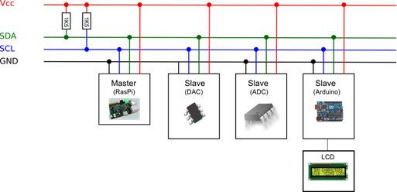
INTRODUCTION

Figure: Principle Drawing of I2C communication
The basic principle of I2C communication is to write to or read from slave using 2 wires namely SDA (SERIAL DATA LINE) and SCL (SERIAL CLOCK LINE). The speciality of the I2C communication is there can N-number of masters and slaves in the circuit that can communicate between themselves. Here we are trying to fetch information from LM75 sensor which is working as a slave and display it on the LCD.

PROJECT DESCRIPTION
The process which is happening in the Temperature logger is explained below.
First, we create an I2C master which controls the temperature sensor. In the master we create a state machine which changes to the conditions which we need. The board DE2-115 provides us with a 50 MHz clock frequency which is way too high for the sensor to work with, so we design a clock divider which lowers the clock frequency and makes the master to work. For the LCD display we need a 400hz clock which is taken from the clock divider which we designed and finally I have taken an external serial clock signal which works with the serial data line, and this was implemented by taking an enable signal from the I2C master and giving it to a D flipflop which acts as a delayer. We have created a temperature register which divides most significant and least significant bits from data and sends it to a component which converts binary numbers into binary coded decimal numbers. This component uses a special algorithm called double dabble. Finally, LCD display is also implemented as a state machine in which each character is displayed is a state mentioned in the design.

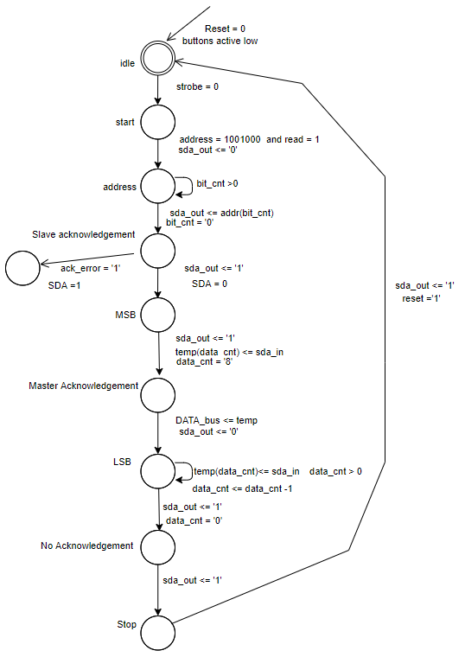

Figure: STATE MACHINE for I2C MASTER

IMPLEMENTATION AND SIMULATION

Clock Divider
 |  | CLOCK DIVIDER
External signals | Port | Width (In bits) | Description
Clk_50 | Input | 1 | Clock signal (50MHz)
Sclk_128 | Output | 1 | Clock signal (200KHz)
Sclk_64 | Output | 1 | Clock signal (100KHz)
Clk_400hz | Output | 1 | Clock signal (400 Hz)
Clk_strobe | Output | 1 | Clock signal (1 Hz)
Sample clock | Output | 1 | Clock signal (1 MHz)

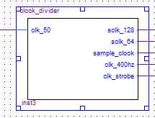
Figure: clock divider BSF
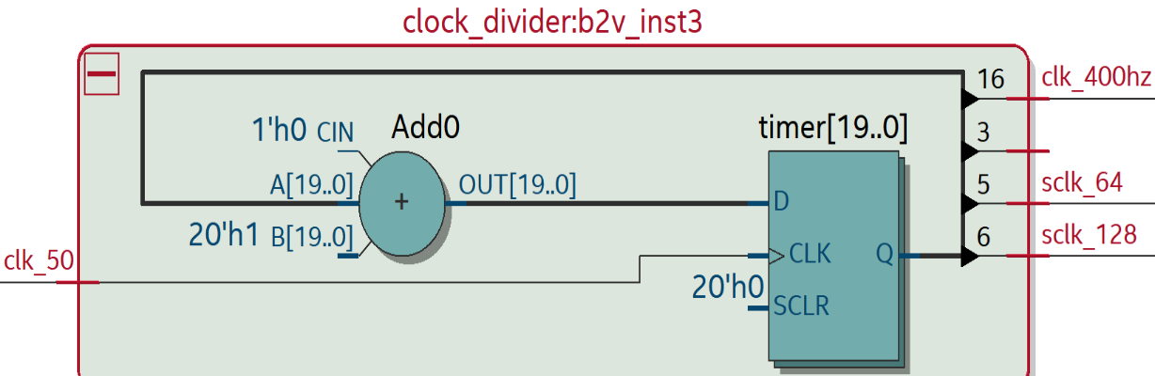

Figure: clock divider RTL
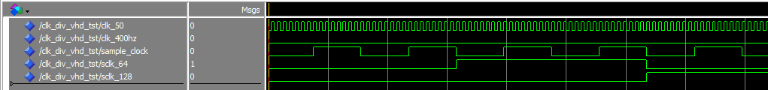
Figure: Clock 50 MHZ is given as input, and it is divided into various clock signals.

I2C MASTER
 |  | I/O Pins
External signals | Port | Width (In bits) | Description
Clk | Input | 1 | Clock signal (200kHz)
Reset | Input | 1 | Global Reset signal from the press button
STROBE | Output | 1 | Strobe signal
Enable | Output | 1 | Enable signal
Data_bus | Output | 16 | 16-bit instruction output

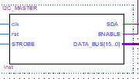
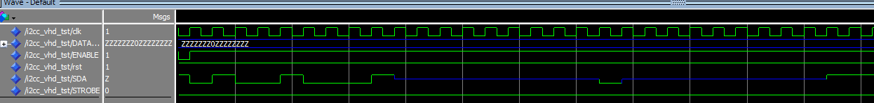
Figure: I2C BSF
Figure: I2C Master simulation

As the SCL is external I have an Enable signal that controls the SCL, and the circuit has reset as ‘0’ as the buttons pushed must be active low.
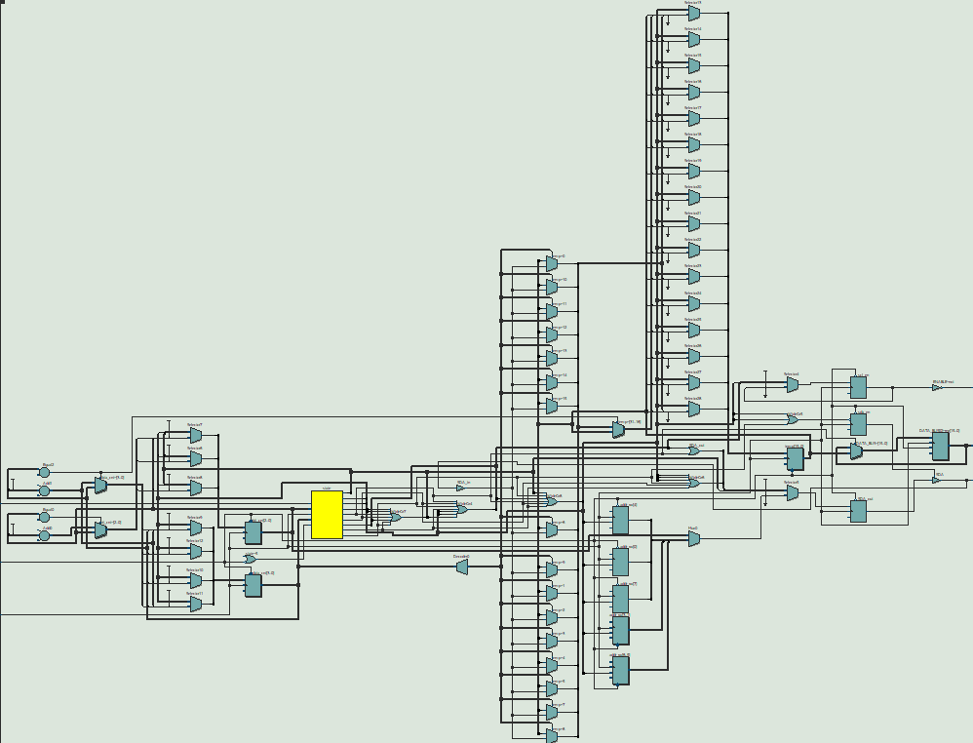
Figure: I2C MASTER RTL

I2C Master will be in read mode as it is reading the information given by the temperature sensor which is slave in the project. This communication is led by 2 wires namely SDA and SCL. I have implemented a I2C Master with an external serial clock. By implementing that way, we have less control over the data flow.

EXTERNAL SERIAL CLOCK
 | EXTERNAL SERIAL CLOCK
External signals | Port | Width  (In bits) | Description
Clock | Input | 1 | Clock signal (100 KHz)
Enable | Input | 1 | Enable signal
CLK_128 | Input | 1 | Clock signal (200 KHz)
SCL | Output | 1 | Serial clock output

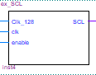

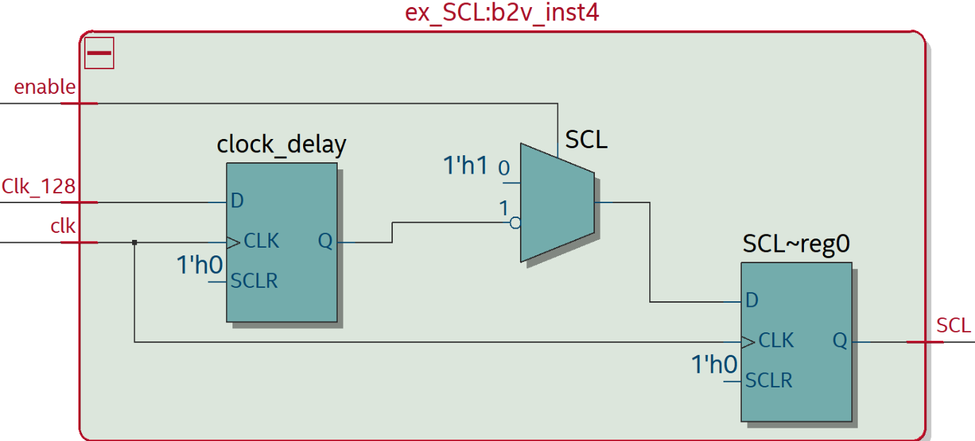
Figure: External Serial Clock BSF
Figure: External Serial Clock RTL

TEMPERATURE REGISTER
 |  | Temperature Register
External signals | Port | Width (In bits) | Description
Temp | Input | 16 | Temperature read from sensor by I2C MASTER
MSB  LSB | Output  Output | 8  1 | Bits 15 down to 8 in the temperature  Bit 7 in the temperature

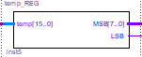

Figure: Temperature register BDF

Binary to BCD CONVERTER
 |  | PROGRAM COUNTER
External signals | Port | Width (In bits) | Description
bin | Input | 8 | MSB from temperature register
BCD | Output | 12 | Converted bits of binary code

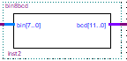

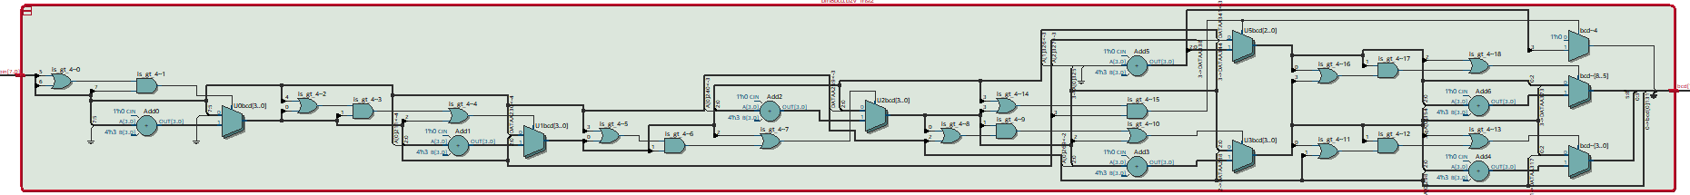
Figure: Binary to BCD converter BDF

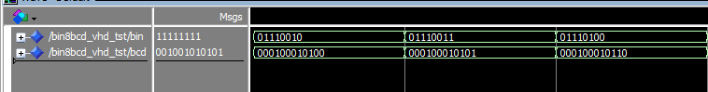
Figure: Binary to BCD converter RTL

Figure: Binary to BCD converter simulation

The converter uses a special algorithm called Double Dabble that helps in the conversion of the binary numbers into binary coded decimal numbers. What the algorithm does is first it takes the first bit of the binary number and checks if the digit is greater than 5 if its less than 5 it leaves the number as it eases and
shifts to right and checks that the numbers are greater than 5 it will add 3 to the number and the procedure continues until no digit is left.

LCD MODULE

 | LCD_MODULE
External signals | Port | Width  (In bits) | Description
Clock | Input | 1 | Clock signal (400 Hz)
Reset | Input | 1 | Reset
MSB | Input | 12 | BCD converted temperature bits
LSB | Input | 1 | LSB from temperature register
LCD_E | Output | 1 | Enable for LCD display
LCD_RS | Output | 1 | Register select for LCD Display
LCD_RW | Output | 1 | Read or Write condition select for LCD Display
LCD_BLON | Output | 1 | Backlight On
LCD_ON | Output | 1 | LCD Display On
LCD_DATA | Output | 8 | LCD Display bits

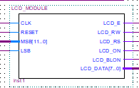

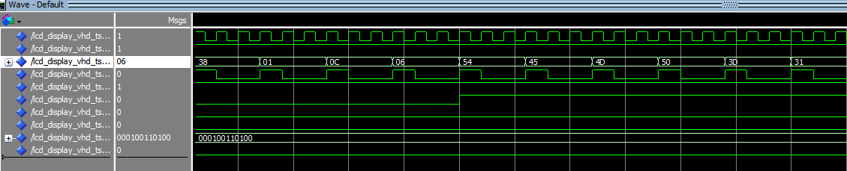
Figure: LCD Module BDF
Figure LCD Display Simulation

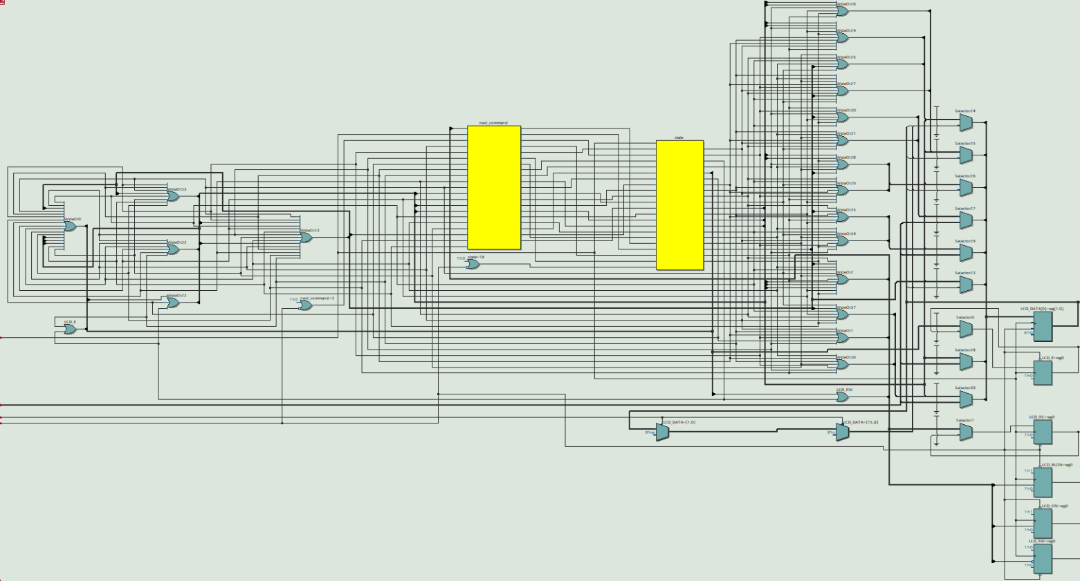

Figure: LCD Module RTL
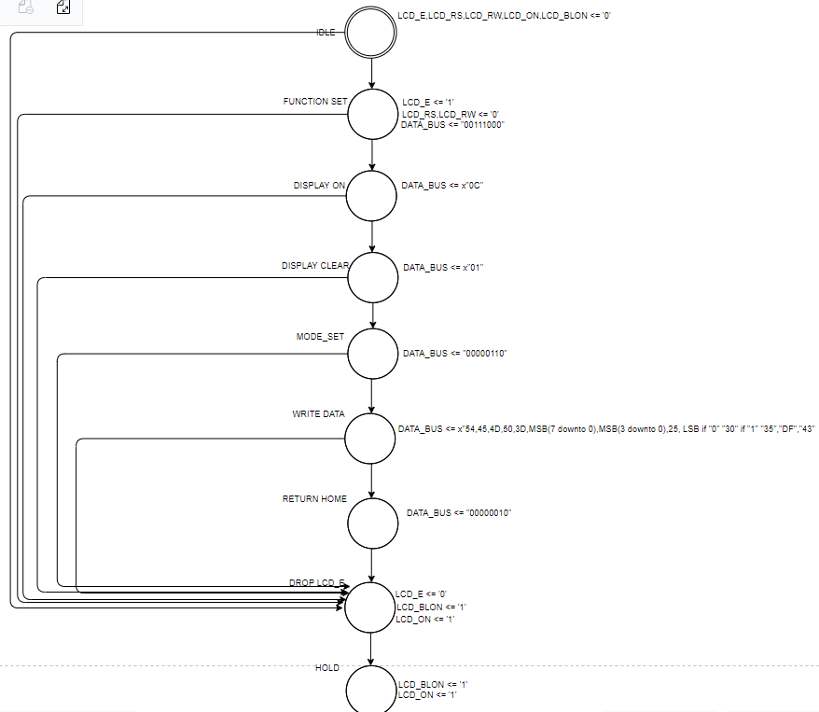

Figure: LCD state machine

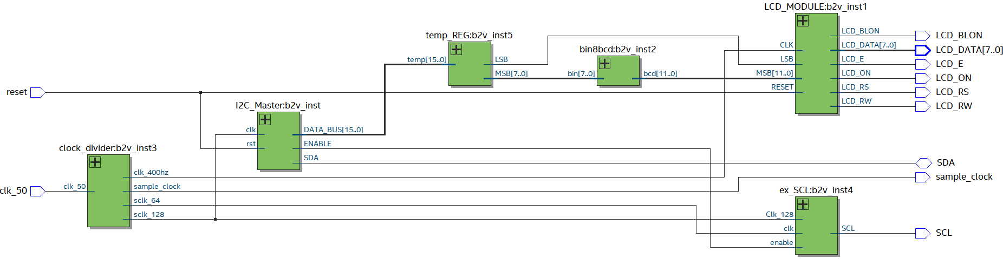
COMPLETE DESIGN RTL

Figure: FULL DESIGN RTL

COMPLETE DESIGN BDF
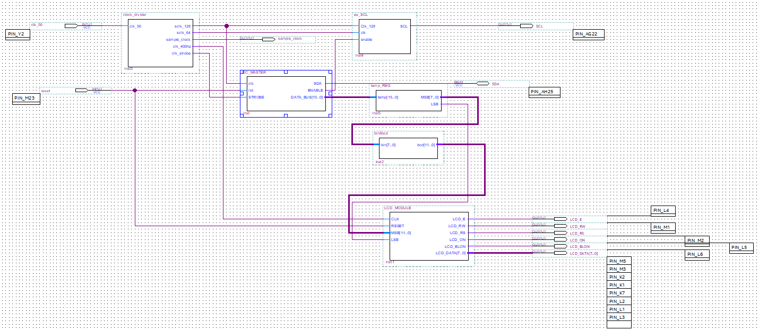
Figure: FULL DESIGN BDF

Temperature Logger working and Results

Temperature logger Working
The latest Temperature detected by LM75 temperature sensor is the output of the project. I2C master communicates with the slave which is temperature sensor in our case using the above-mentioned communication technique called I2C communication.
First, we create a I2C master with an external serial clock which communicates with slave using serial data line and external serial clock which is connected using an enable which is an output from the I2C master. The temperature detected is displayed on LCD display which is inbuilt in the DE2-115 board. This whole process is done using Quartus II compiler and have been coded using VHDL.
I2C master is a state machine which works according to i2c communication protocol. in I2C communication we can have multiple master and slave devices which are connected using 2 wires. Basically, the master communicates with slave by writing address of the slave to the SDA line. Slave responds to the master by giving an acknowledgement to the SDA line we call it the slave acknowledgement. After slave’s response it start writing data to SDA line that master starts reading of. After reading significant data bits master send an acknowledgement and then slave sends the remaining data. When the data read is sufficient master sends a no acknowledgement which trigger the stop condition.
I2C master works on a clock signal which runs on the clock frequency of 200KHz, external serial clock runs on clock frequency of 100 KHZ and LCD display runs on clock frequency of 400Hz, but DE2-115 provides us with a clock with the frequency of 50MHz, so we use a clock divider which divides the clock and distributes the appropriate clock frequency for the respective component.
I2C master gives out a data which is 16 bits longs and the important bits for us are 9 so we have a temperature register which divides the 16 bits data into 9 bits and that 9-bit data is sent out as MSB which is first 8 bits f the 15 bits data and LSB which is 9th bits of that 16-bit data.
This MSB is a binary data, and we need binary coded decimal data for the LCD data. Therefore, we must convert this binary data to BCD. We use a binary to BCD converter which uses a special algorithm called double dabble. This double dabble is a twostep process. First, we take an 8-bit binary number, and we shift to the left and check whether the number is greater than or equal to 5 if it’s not equal to 5 we shift one more bit to the left and check if the numbers are or equal to or greater than 5 if they are, then we add 0011 to the bits. we continue this process until no data bits are left. We get a BCD number as an output.
Finally, this BCD number is shown on the LCD display on the board. This BCD number is again gets converted into an ASCII code for displaying the temperature. The objective of determining the temperature as the desired outcome of the project is dependent on the first four bits, where if the 11th bit is 1 then the temperature detected is negative and if its 0 then the temperature is positive and if LSB is 0 then the granularity of the temperature is 0 and when 1 its 0.5.the whole project is implemented on Celsius scale of temperature.

RESULTS

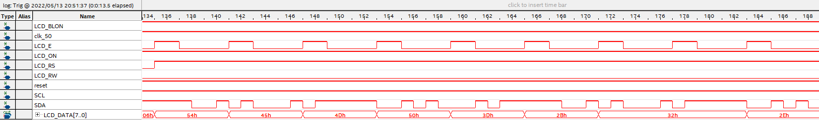
We have achieved the desired output by implementing the above-mentioned working using VHDL code and the results are shown in the below signal tap and picture of the board showing different temperatures.

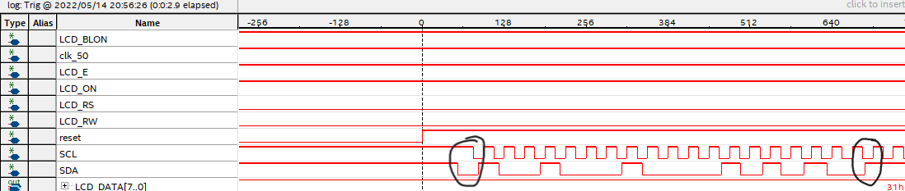
CLK_50 and SCL signals are very fast when compared to the clock of lcd display so I have made the sample clock slower for getting a reasonable wave form of the temperature logger.

Here I have introduced a much faster sample clock of frequency 1 MHz, so we got a clear SCL wave form.
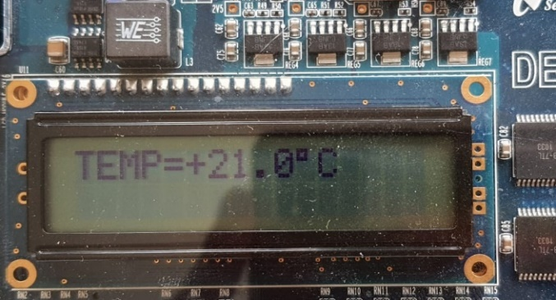
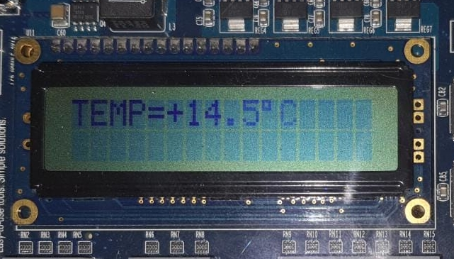

CONCLUSION
The objective of building a temperature logger system using temperature sensor LM75 gave results as expected which are in line with the requirements specifications with a few minor discrepancies. Understanding the concepts of I2C communication were the pivotal factors and served as an important base in building the temperature logger system. Key aspects like the communication between the DE2-115 and the temperature sensor were the fundamental building blocks of the project.

Appendix A: Source code

Clock divider:
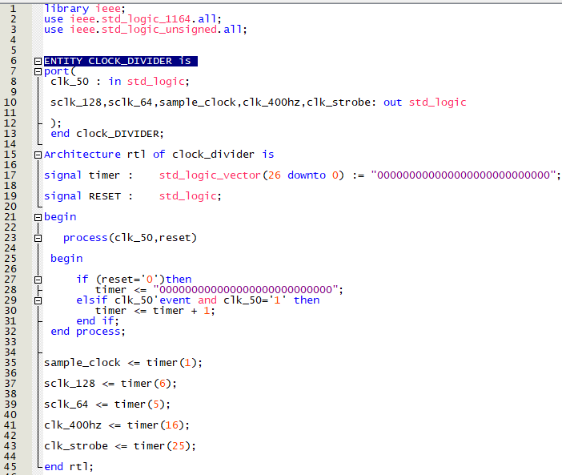

External Serial Clock:

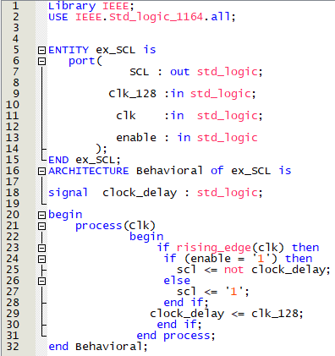

Temperature Register:

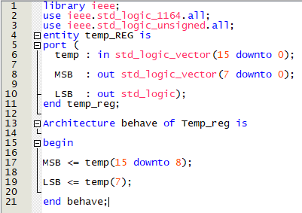

Binary to BCD converter:
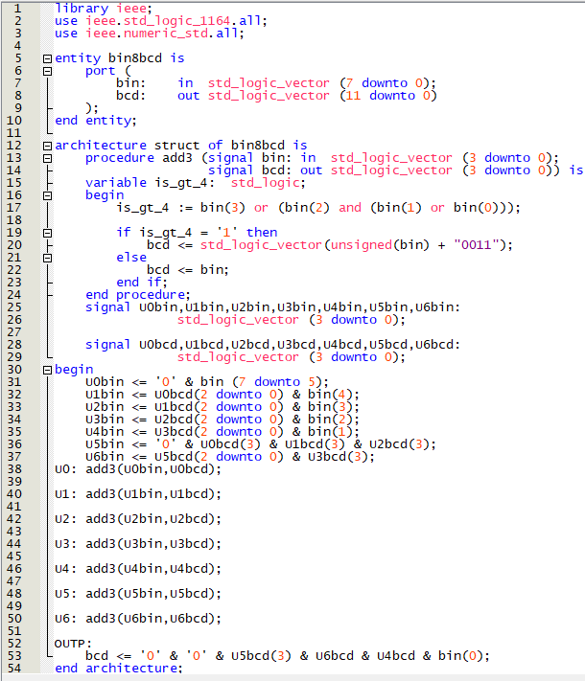

I2C Master
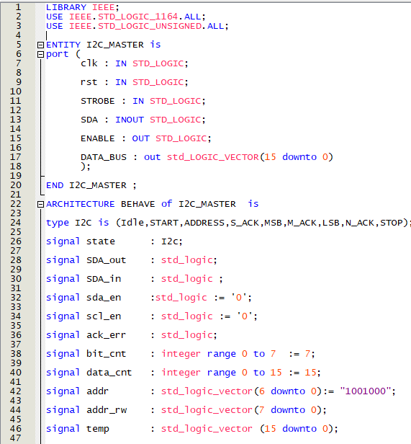

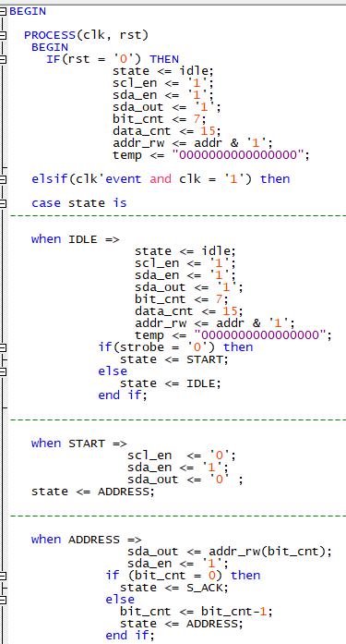

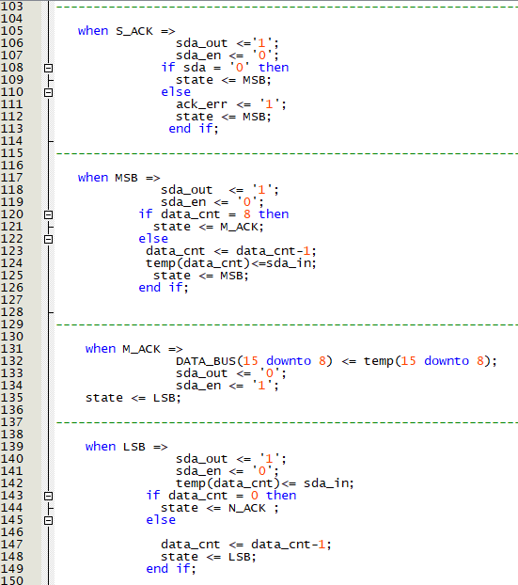

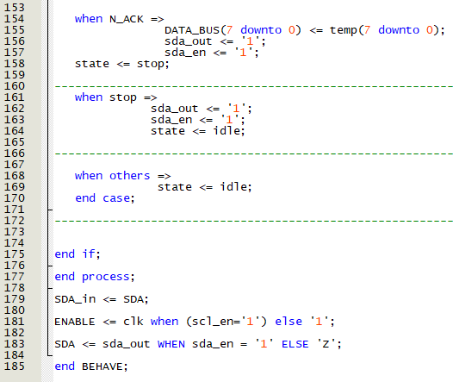

LCD Module:
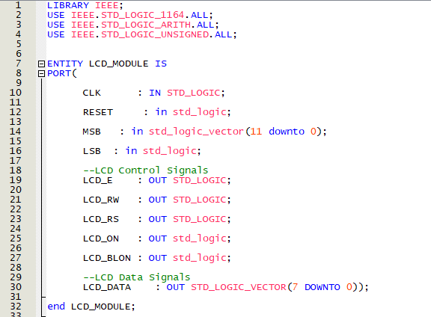

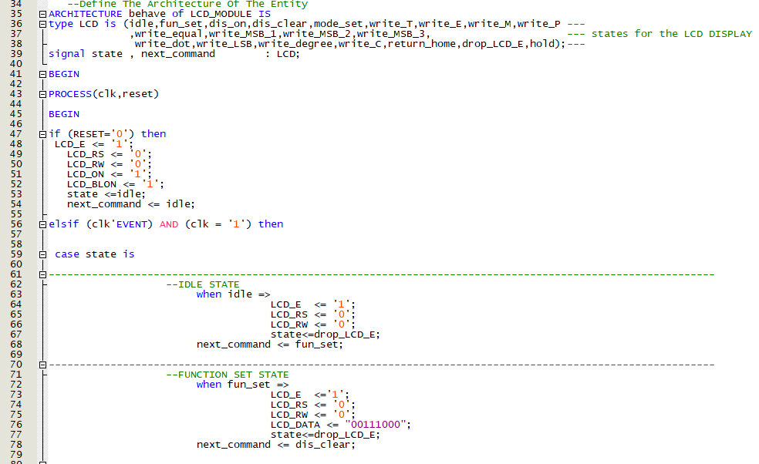

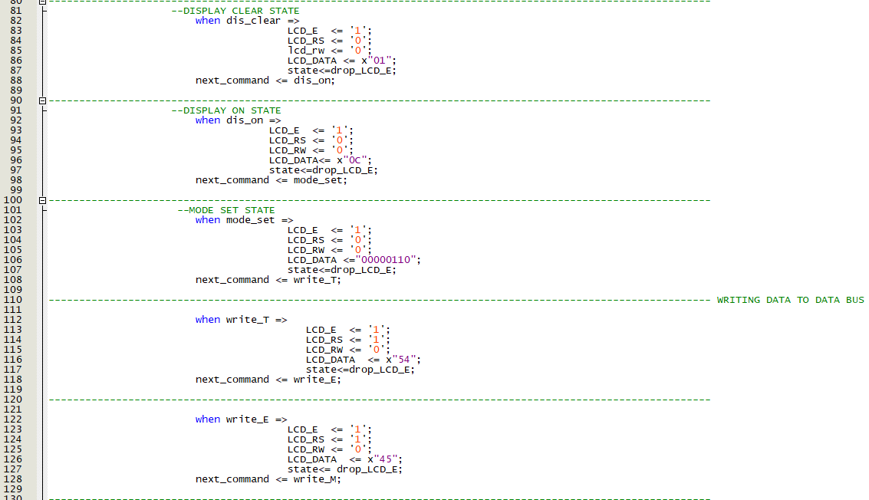
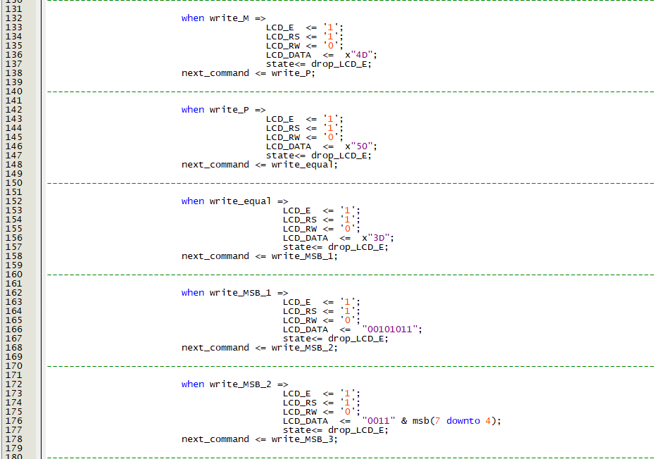

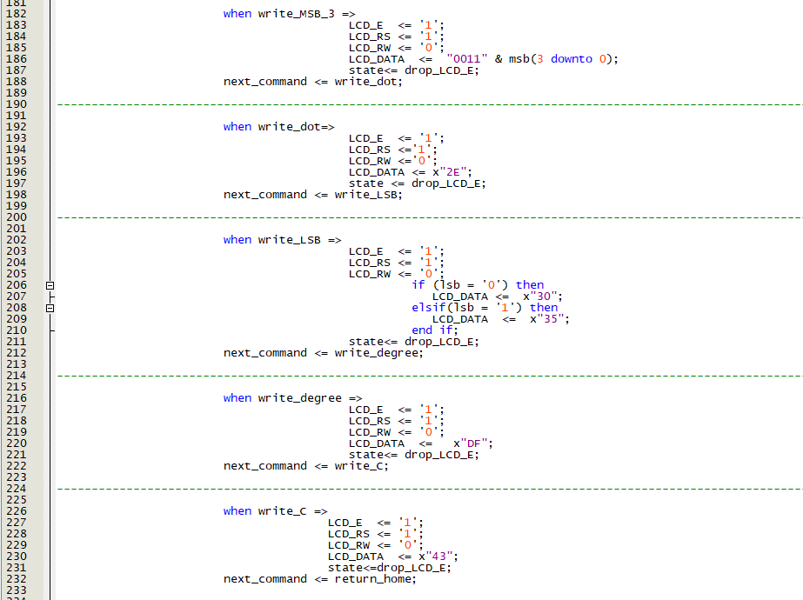

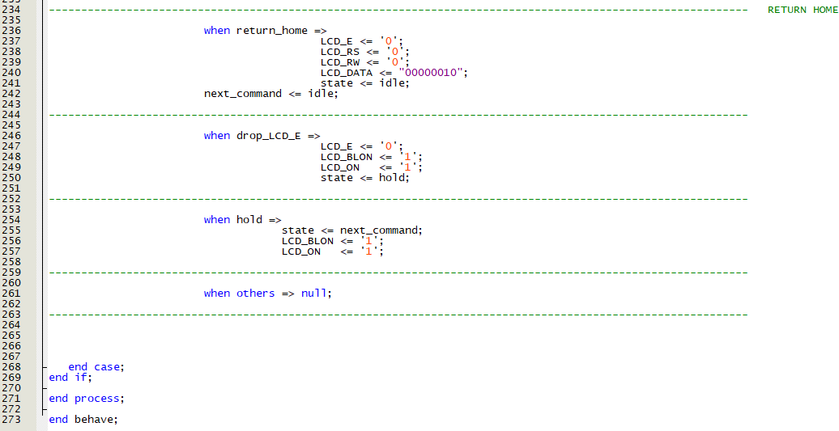

REFERENCES
- VHDL for designers, book written by Stefan Sjoholm and Lennart Lindh
- For clock divider: https://www.youtube.com/watch?v=GYj_G6KVP1Y&t=124s
- For I2C Master: Material provided by the faculty during beginning of the project
- For Binary to BCD converter: https://www.youtube.com/watch?v=yki0PkBcJbg&t=182s
- For LCD display: https://www.youtube.com/watch?v=z9PQb7XoceM&t=1093s
- For rest of registers and debugging: Labs performed during the course .

